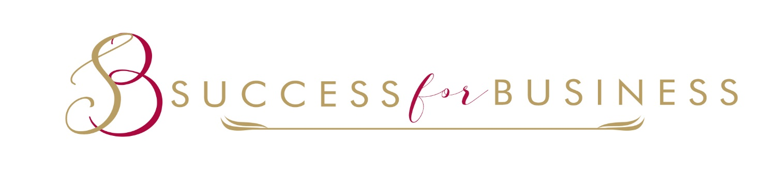
My professional background at a quick glance:
Susan Bálint(CerTEFL,FTBE)
- ▪ELTE English Linquistics and Literature
▪Oxford House College-Teaching English for Business and Adult Education
▪Personal and Business&Executive Coaching –Work based and integrated studies, University of Chester
▪Presentation and Negotiation technics
▪KLTE Debrecen- Faculty of Pedagogy and Psychology, Communication skills
▪Further Certificate for Teachers of BusinessCommunication , London Chamber of Commerce and Industry(www.eurolinkhungary.co.hu)
▪Counseling,career choices,conflict resolution
▪Sexuality, sex education
The use of Adlerian Psychology Management-Kath &Frank Walton, South Carolina, USA
Life Coaching(in Hungarian Language )
▪Hungarian corespondent of the International Coaching News
▪President of the Pest Coaching Support Group
▪Member of the International Regulator of Coaching & Mentoring
▪ Strategic partner of Noble Manhattan Coaching company UK
▪BOSI Affiliate-Entrepreneur DND &Portfolio Program(USA)
▪WBECS Partner
Life long learning is very important for me,every year I attended the World Business & Executive Coach Summit online conference where I had the chance to listen more than 40 lectures from the most famous coaches and leaders.Beside this I usually take part in different international conferences and webinars.
Charity:
▪AdjunkÁlmokat(www.adjunkalmokat.hu)
▪International Women’s Club (www.iwcbudapest.hu)

